# <Guest> Login

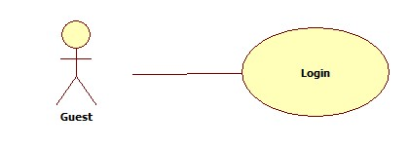

|  |  |  |  |  |
| --- | --- | --- | --- | --- |
| **USE CASE - LOGIN** | | | | |
| **Use-case No.** | UC01 | **Use-case Version** | | 1.0 |
| **Use-case Name** | Login | | | |
| **Author** | Tinbn | | | |
| **Date** | 29/05/2014 | **Priority** | High | |
| **Actor:**   * Guest who already had an account created by doctor.   **Summary:**   * Login into system   **Goal:**   * Check user’s role to use system’s functions.   **Triggers:**   * Click on “Đăng nhập” to login   **Preconditions:**   * Page is loaded successfully. * Users are in “Homepage”page.   **Post Conditions:**   * Success: member login successfully. * Failure: System displays error message. Content of error message will specify in Exception section.   **Main Success Scenario:**   |  |  |  | | --- | --- | --- | | Step | Actor Action | System Response | |  | 1. Click “Đăngnhập” link on homepage | 2. Display a form and request to enter user’s information. | |  | 3. Fill username and password. [Alternative1] |  | |  | 4. Click “Đăngnhập”button. | 5. Validate username and password, redirect to home page, show message: “Xin chào [username] đã đăng nhập thành công”. |   **Alternative Scenario:**   |  |  |  | | --- | --- | --- | | No. | Actor Action | System Response | |  | 3.1 [Alternative1] Click “Thoát” button. | 3.2 Redirect to main page. |   **Exceptions:**   |  |  |  | | --- | --- | --- | | No. | Actor Action | System Response | | 1 | When user fills wrong username or password. | Display a hint message “Tên đăng nhập hoặc mật khẩu không đúng, xin thử lại". | | 2 | When network disconnected. | Display an informed message”Kết nối mạng bị lỗi.” | | 3 | Username or password is blank. | Show message: “Username hoặc password không đuợc để trống”. |   **Relationships:**  **N/A**  **Business Rules:**   * After 5 times wrong, the system will lock account for 30 minutes | | | | |

# <Guest> Register

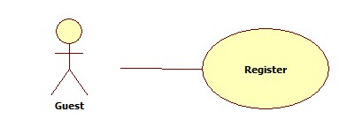

|  |  |  |  |  |
| --- | --- | --- | --- | --- |
| **USE CASE – REGISTER** | | | | |
| **Use-case No.** | UC02 | **Use-case Version** | | 1.0 |
| **Use-case Name** | Register | | | |
| **Author** | Tinbn | | | |
| **Date** | 30/05/2014 | **Priority** | High | |
| **Actor:**   * Guest   **Summary:**   * User uses this function to register into system.   **Goal:**   * Help guest to create an account on website.   **Triggers**   * Click on “Đăng ký” to register.   **Pre-conditions:**   * Page is loaded successfully * Register page will be shown   **Post conditions:**   * Guest become member of website   **Main Success Scenario:**   |  |  |  | | --- | --- | --- | |  | Actor Action | System Response | |  | 1. Click on “Đăng ký” link on homepage | 2. Display Register page. | |  | 3. Fill all mandatory fields |  | |  | 4. Click on [Đồng ý] button | 5. Validate the inputted information and save to database. When it’s done show message ”Bạn đã đăng ký thành công” |   **Alternative Scenario:**   * **N/A**   **Exceptions:**   |  |  |  | | --- | --- | --- | | No. | Actor Action | System Response | | 1 | “Tên đăng nhập” text-box is empty | Display message:”Bạn chưa điền tên thành viên. Xin vui lòng thử lại!” | | 2 | When user fills username is more than 15 characters or less than 8 characters | Display message “Tên đăng nhập phải từ 8 đến 15 ký tự. Xin vui lòng thử lại!” | | 3 | When user fills exist username | Display message “Tên đăng nhập bạn chọn đã được sử dụng, xin vui lòng thử tên khác” | | 4 | Mandatory field which have a mark ”*” is empty | Display message “Thông tin của bạn chưa đúng” doesn’t fill information has “*" | | 5 | When user fills password is more than 15 characters or less than 8 characters | Display message “Mật khẩu phải từ 8 đến 15 ký tự. Xin vui lòng thử lại!” |   **Relationships:**   * Create Request   **Business Rules:**   * All information need to fill correct * Users are in “Đăng ký” page | | | | |

# <Admin> Manage Doctor

|  |  |  |  |  |
| --- | --- | --- | --- | --- |
|  | | | | |
|  |  |  | |  |
|  |  | | | |
|  |  | | | |
|  |  |  |  | |
|  | | | | |

# <Admin> Change Medical Profile Layout

|  |  |  |  |  |
| --- | --- | --- | --- | --- |
|  | | | | |
|  |  |  | |  |
|  |  | | | |
|  |  | | | |
|  |  |  |  | |
| **Actor:**  **Sumary:**  **Goal:**  **Trigger:**  **Precondition:**  **Postcondition:**  **Main Success Scenario:**  **Alternative Scenario:**  **Exceptions:**  **Relationships:** | | | | |

# <Authorized User> Change Profile Picture

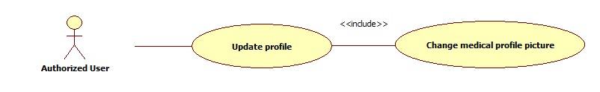

|  |  |  |  |  |
| --- | --- | --- | --- | --- |
| **USE CASE – CHANGE MEDICAL PROFILE PICTURE** | | | | |
| **User-case No.** | UC05 | **Use-case Version** | | 1.0 |
| **User-case Name** | Change Medical Profile Picture | | | |
| **Author** | Tinbn | | | |
| **Date** | 30/05/2014 | **Priority** | Medium | |
| **Actor:**   * Authenticated User: Admin, patient, doctor   **Sumary:**   * This use case is about change medical profile picture   **Goal:**   * Help user to change their medical profile picture   **Trigger:**   * Click on profile picture in “profilepage” and select “Thay đổi ảnh đại diện” to change medical profile picture.   **Precondition:**   * Page is loaded successfully. * Users have already logged in.   **Postcondition:**   * Succeed: User’s medical profile picture changed. * Failure: System displays error message. Content of error message will specify in Exception section.   **Main Success Scenario:**   |  |  |  | | --- | --- | --- | | Step | Actor Action | System Response | |  | 1. Click on “Profile picture” link on profile page and select “Thay đổi ảnh đại diện”. [Alternative1] | 2. Display a “change profile picture box”. | |  | 3. Select an template profile picture or upload owner’s picture. |  | |  | 4. Click on [Đồng ý] button. | 5. Save to database. When it’s done show message ”Bạn đã thay đổi ảnh đại diện thành công” |   **Alternative Scenario:**   * N/A   **Exceptions:**   |  |  |  | | --- | --- | --- | | No. | Actor Action | System Response | | 1 | When network disconnected. | Display an informed message “Kết nối mạng bị lỗi.” | | 2 | When session timeout. | Display an informed message”Thời gian thực thi của bạn đã hết. Vui lòng đăng nhập lại.” |   **Relationships:**   * After login successfully, user can change their password.   **Business Rules:**   * Users have logged in already. | | | | |

# <Authorized User> Change Password

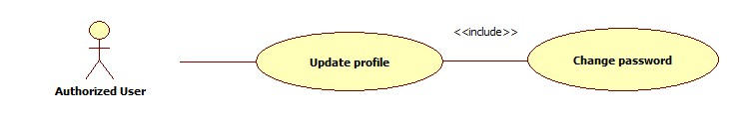

|  |  |  |  |  |
| --- | --- | --- | --- | --- |
| **USE CASE – CHANGE PASSWORD** | | | | |
| **Use-case No.** | UC06 | **Use-case Version** | | 1.0 |
| **Use-case Name** | Change Password | | | |
| **Author** | Tinbn | | | |
| **Date** | 29/05/2013 | **Priority** | Medium | |
| **Actor:**   * Authenticated User: Admin, patient, doctor.   **Sumary:**   * This usecase is about changing password for user.   **Goal:**   * User can change their password.   **Trigger:**   * Click on “Đổi mật khẩu” button in “profilepage” to change password.   **Precondition:**   * Page is loaded successfully. * Users have already logged in.   **Postcondition:**   * Succeed: User’s password changed. * Failure: System displays error message. Content of error message will specify in Exception section.   **Main Success Scenario:**   |  |  |  | | --- | --- | --- | | Step | Actor Action | System Response | |  | 1. Click “Đổi mật khẩu” link on profile page. [Alternative1] | 2. Display a “change password box”. | |  | 3. Fill all mandatory fields. |  | |  | 4. Click on [Đồng ý] button. | 5. Validate the inputted information and save to database. When it’s done show message ”Bạn đã thay đổi mật khẩu thành công” |   **Alternative Scenario:**   * N/A   **Exceptions:**   |  |  |  | | --- | --- | --- | | No. | Actor Action | System Response | | 1 | When network disconnected. | Display an informed message “Kết nối mạng bị lỗi.” | | 2 | When session timeout. | Display an informed message”Thời gian thực thi của bạn đã hết. Vui lòng đăng nhập lại.” | | 3 | When “Mật khẩu cũ” was not match | Display an informed message “Vui lòng nhập đúng mật khẩu hiện tại”. | | 4 | When “Mật khẩu mới” field was not match with “Lặp lại mật khẩu” field | Display an informed message “Lặp lại mật khẩu không khớp. Vui lòng kiểm tra lại”. |   **Relationships:**   * After login successfully, user can change their password.   **Business Rules:**   * Users have logged in already. | | | | |

# <Authorized User> Logout

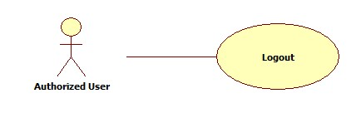

|  |  |  |  |  |
| --- | --- | --- | --- | --- |
| **USE CASE – LOG OUT** | | | | |
| **Use-case No.** | UC07 | **Use-case Version** | | 1.0 |
| **Use-case Name** | Logout | | | |
| **Author** | Tinbn | | | |
| **Date** | 29/05/2013 | **Priority** | High | |
| **Actor:**   * Authenticated User: Admin, patient, doctor   **Summary:**   * Log out system   **Goal:**   * Help user to log out their account.   **Triggers:**   * Click on “Đăng xuất” to log out   **Preconditions:**   * Page is loaded successfully. * Users have already logged in.   **Post Conditions:**   * Success: users log out successfully. * Failure: System displays error message. Content of error message will specify in Exception section.   **Main Success Scenario:**   |  |  |  | | --- | --- | --- | | Step | Actor Action | System Response | |  | 1. Click “Đăng xuất” link on main page. [Alternative1] | 2. Display a confirm box. | |  | 3. Click “Có” button. [Alternative2] | 4. Logout user, redirect to Home page, logout successfully. |   **Alternative Scenario:**   |  |  |  | | --- | --- | --- | | No. | Actor Action | System Response | |  | 1.1 [Alternative1] Click “Đăngnhập”link on main page. | 1.2 Display a confirm box. | |  | 3.1 [Alternative1] Click “Không” button in confirm box. | 3.2 Close confirm box. Log out fail. |   **Exceptions:**   |  |  |  | | --- | --- | --- | | No. | Actor Action | System Response | | 1 | When network disconnected. | Display an informed message “Kết nối mạng bị lỗi.” | | 2 | When session timeout. | Display an informed message”Thời gian thực thi của bạn đã hết. Vui lòng đăng nhập lại.” |   **Relationships:**   * After login successfully, user can log out or edit their profile.   **Business Rules:**   * Users have logged in already. | | | | |